There is many ways to implement defence on SQL injection
You can implement prepared statement using either using the PDO( PHP Data Objects) or my SQLi extension
I have explained what is SQL injection how there is different types of SQL injection attacks and it is the shared OneDrive
The use of PDO, it is preferred method because it works with multiple database types and supports named parameters.
Prepare an SQL query with empty values as a placeholder with either a question mark or a variable name with a colon preceding It for each value
Blind values or variable to the placeholders
Execute query simultaneously
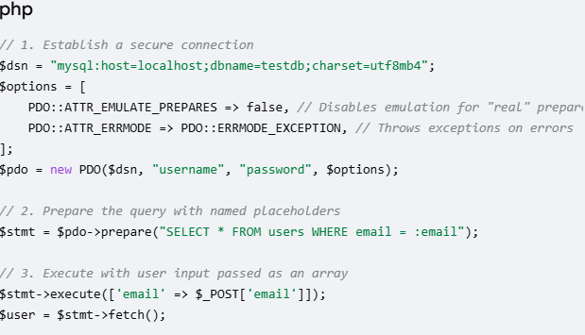
There is another option if you prefer MySQL
Basic workflow
The prepared statement execution consists of two stages: prepare and execute. At the prepare stage a statement template is sent to the database server. The server performs a syntax check and initializes server internal resources for later use.
The MySQL server supports using anonymous, positional placeholder with?.
Prepare is followed by execute. During execute the client binds parameter values and sends them to the server. The server executes the statement with the bound values using the previously created internal resources.
1 prepared statement
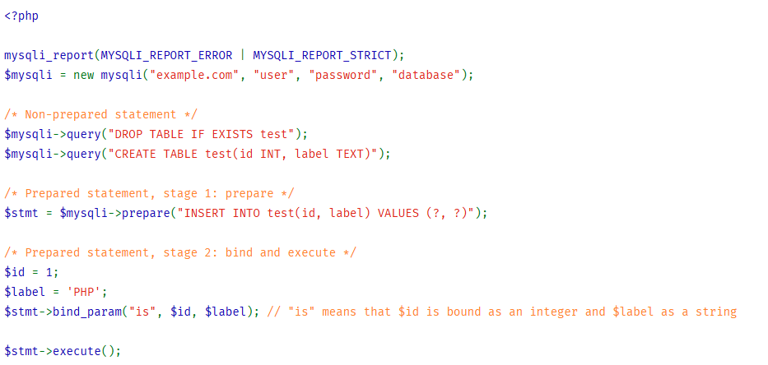
Repeated execution
A prepared statement can be executed repeatedly. Upon every execution the current value of the bound variable is evaluated and sent to the server. The statement is not parsed again. The statement template is not transferred to the server again.
2 insert prepared once. Executed multiple times
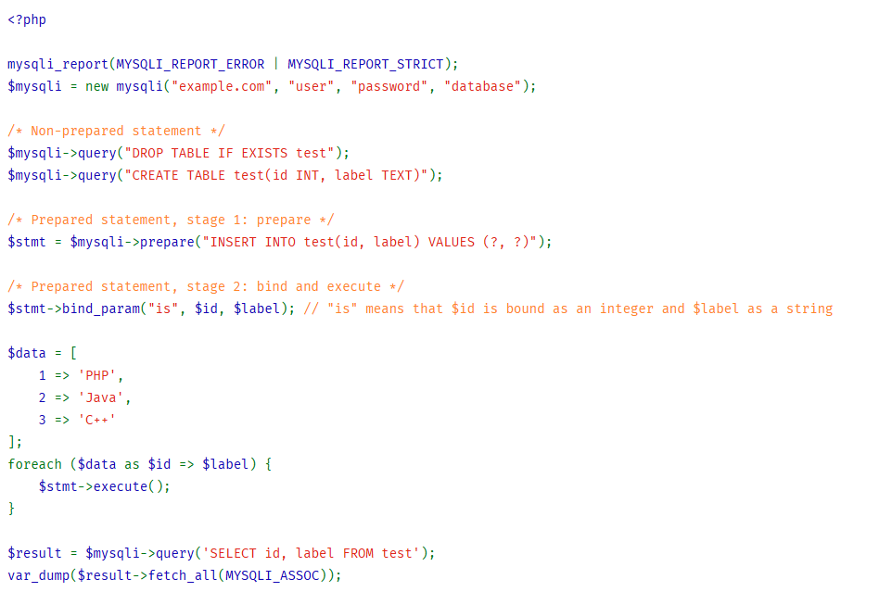
I found this detailed on this websited.
https://www.php.net/manual/uk/mysqli.quickstart.prepared-statements.php

